**WEEK 2 & 3**

**Problem SET 2**

**DEMAND AND SUPPLY**

**PART A:**

1. If a rise in the price of gasoline decreases the demand for large cars,

a. gasoline and large cars are substitutes in consumption.

b. gasoline and large cars are complements in consumption.

c. gasoline is an inferior good.

d. large cars are an inferior good.

2. For consumers, pizza and hamburgers are substitutes. A rise in the price of pizza ____ the price of a hamburger and ____ in the quantity of hamburgers.

a. raises; increases

b. raises; decreases

c. lowers; increases

d. lowers; decreases

3. Gruel is an inferior good. Hence, a decrease in people's incomes

A) shifts the supply curve of gruel leftward.

B) shifts the demand curve for gruel rightward.

C) shifts the demand curve for gruel leftward.

D) decreases the quantity of gruel supplied.

4. An unusually warm winter

A) shifts the supply curve of gloves leftward.

B) shifts the demand curve for gloves rightward.

C) shifts the demand curve for gloves leftward.

D) shifts the supply curve of gloves rightward.

5. Wages for workers producing Walkmans and similar products will rise next year. Walkman Watch asks you to predict the effect of this change in next year's market for Walkmans. You predict that the major effect will be that the

A) demand curve for a Walkman will shift leftward.

B) supply curve for a Walkman will shift rightward.

C) supply curve for a Walkman will shift leftward.

D) demand curve for a Walkman will shift rightward.

6. The number of firms producing computer memory chips decreases. As a result, the price of a memory chip ____ and the quantity of memory chips ____.

a. rises; increases

b. rises; decreases

c. falls; increases

d. falls; decreases

7. An increase in the expected future price of a good

A) has no effect on either its demand or its supply.

B) increases its demand.

C) decreases its demand.

D) increases its supply

**PART B:**

1) New cars are normal good. Suppose that the economy enters a period of strong economic expansion so that people’s incomes increase substantially. Use a supply and demand diagram to determine what happens to the equilibrium price and quantity of new cars.

**ANSWER**

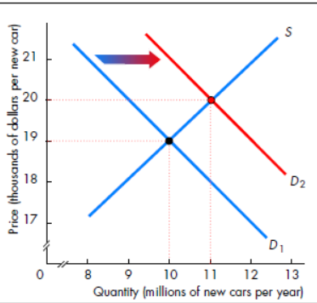

**FIGURE 1**

Because new cars are a normal good, an increase in income increases the demand for them. Hence, the demand curve shifts rightward, as shown in Figure 1. As a result, the equilibrium price rises (from $19,000 to $20,000 in the figure) and the equilibrium quantity also increases (from 10 million a year to 11 million in the figure).

2a) The market for chickens initially is in equilibrium. Suppose that eating buffalo wings (which, contrary to the name, are made from chicken wings) becomes so stylish that people eat them for breakfast, lunch, and dinner. Use a supply and demand diagram to determine how the

equilibrium price and quantity of chicken change.

b) Return to the initial equilibrium, before eating buffalo wings became stylish. Now suppose that a heat wave occurred and caused tens of thousands of chickens to die or commit suicide. Keeping in mind that dead chickens cannot be marketed, use a supply and demand diagram to

determine what happens to the equilibrium price and quantity of chicken.

c) Now assume that both the heat wave and fad strike (craze for chicken wings) at the same time. Use a supply and demand diagram to show what happens to the equilibrium price and quantity of chicken.

**ANSWER:**

**(a)**

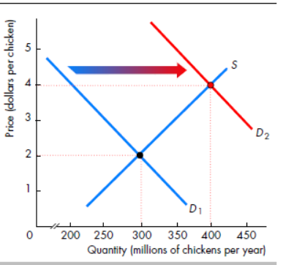

**FIGURE 2**

price rises (from $2 to $4 per chicken) and the equilibrium quantity of chickens increase (from

300 million to 400 million). Note that the change in people’s preferences does not affect the

supply of chicken, so the supply curve does not shift.

**(b)**

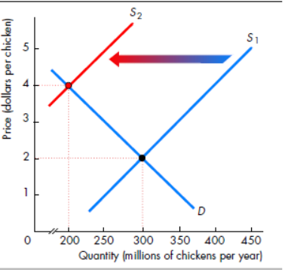

**FIGURE 3**

The heat wave decreases the number of chickens that can be supplied. This change shifts the supply curve for chickens leftward, as Figure 3 shows. As a result, the heat wave raises the price of a chicken (from $2 to $4) and decreases the quantity (from 300 million to 200 million).

**(c)**

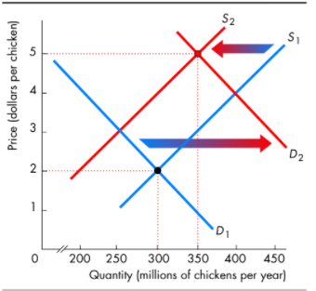

**FIGURE 4**

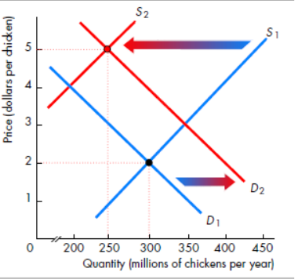

**FIGURE 5**

c. If the demand increases and the supply decreases, the equilibrium price of a chicken rises. But the effect on the quantity is ambiguous. Figures 4 and 5 reveal the nature of this ambiguity. In Figure 4, the demand shift is larger than the supply shift, and the equilibrium quantity increases to 350 million chickens. But in Figure 5, the magnitude of the shifts is reversed, and the supply shift exceeds the demand shift. Because the supply shift is larger, the equilibrium quantity decreases to 250 million chickens. So unless you know which shift is larger, you cannot determine whether the quantity increases (when the demand shift is larger); decreases (when the supply shift is larger); or stays the same (when both shifts are the same size). However, regardless of the relative sizes, Figures 4 and 5 show that the price will unambiguously rise, coincidentally to $5 in both figures.

3) The rent control agency of New York City has found that aggregate demand is QD = 100 - 5P.

Quantity is measured in tens of thousands of apartments, Price, the average monthly rental rate, is measured in hundreds of dollars. The agency also noted that the increase in Q at

lower P results from more three-person families coming into the city from Long island and

demanding apartments. The city's board of realtors acknowledges that this is a good demand

estimate and has shown that supply is QS = 50 + 5P.

if both the agency and the board are right about demand and supply, what is the free

market price? What is the change in city population If the agency sets a maximum average

monthly rental of S100, and all those who cannot find an apartment leave the city?

**Answer: QD = 100-5P….(1) QS = 50+5P….(2)**

**In equilibrium, demand = supply**

**QD = QS**

**100-5P=50+5P**

**5P+5P=100-50**

**10P=50**

**P=5**

**QD= 100-5(5)= 75**

**QS= 50+5(5)= 75**

**P* = 500**

**Q* = 750000**

**P=1,**

**QD’= 100-5(1)= 95**

**QS’ = 50+5(1) = 55**

**Shortage = 95-55 = 400,000**

**There are 3 persons per apartments**

**Therefore, 3*40000 = 1,200,000 people will leave the city.**

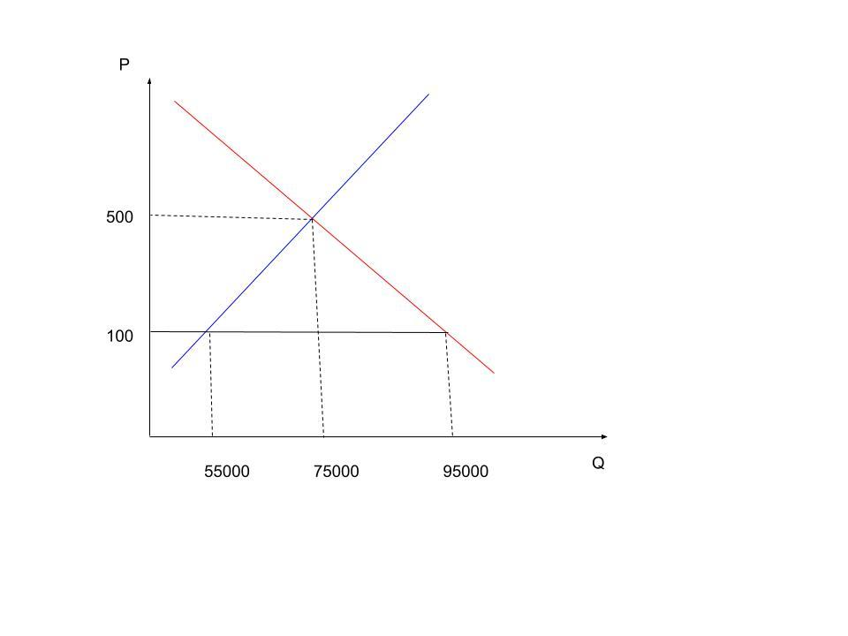

**ANSWER:**

**1-Answer (B)** The definition of complementary goods is that a rise in the price of one decreases the demand for the other.

**2- Answer (A)** A change in preferences shifts the demand curve, not the supply curve.

**3- Answer (B)**

**4- Answer (c)**

**5- Answer (C)**

**6- Answer (B)** The decrease in the number of firms producing memory chips decreases the supply of memory chips, which raises the price and decreases the quantity of chips.

**7- Answer (B)**